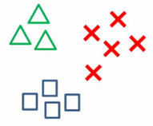

ALGORITHM MULTI CLASS

**In this session**

* Multi Class Algorithms in Azure ML
* Data importing and engineering
* Feature engineering
* Modeling and evaluation
* Reuter Data set
* Edit Metadata
* Confusion Matrix

Multi Class Algorithms in Azure ML

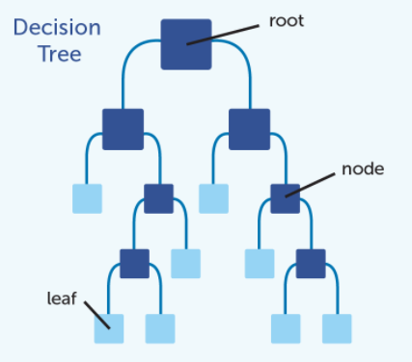

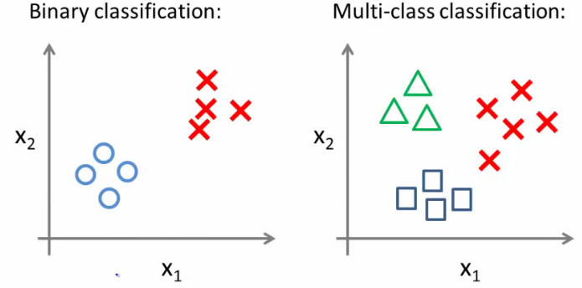

Multiclass Decision Forest

* Based on the decision forest algorithm
* Rapidly builds a series of decision trees
* learning from tagged data.
* Voting on the most popular output class
* Voting is a form of aggregation

Over all Experiment

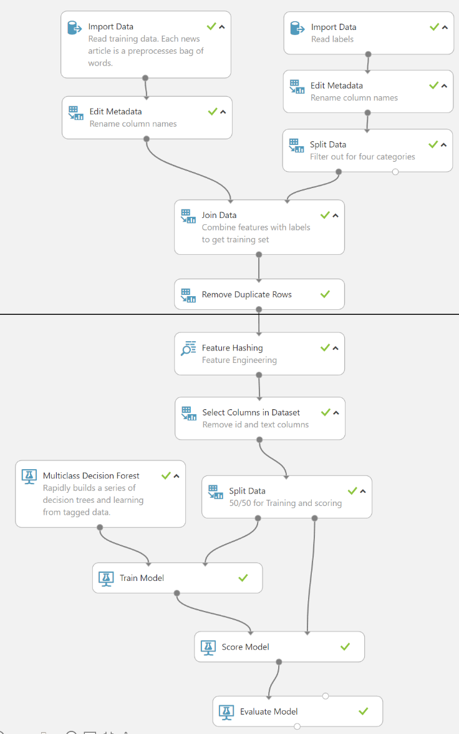

* multiclass classifiers
* Feature engineering using hashing
* Classify news into four categories

Data importing and engineering

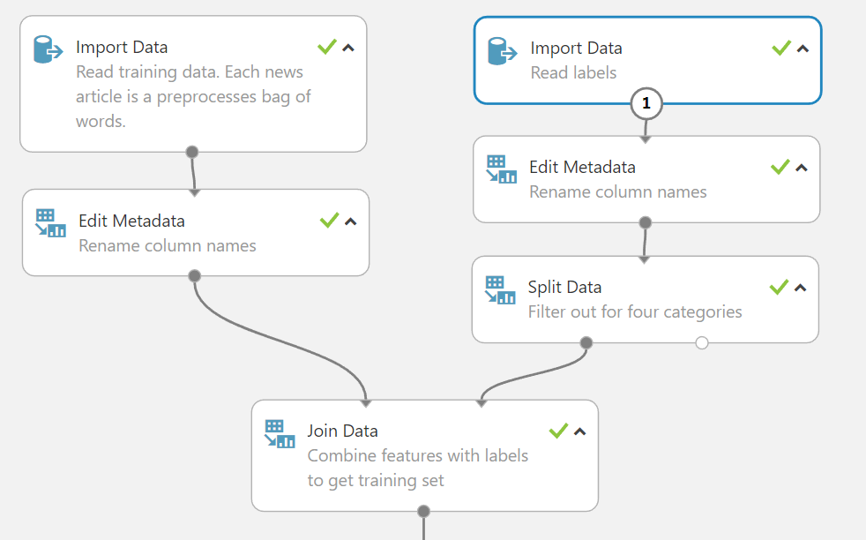

Feature engineering

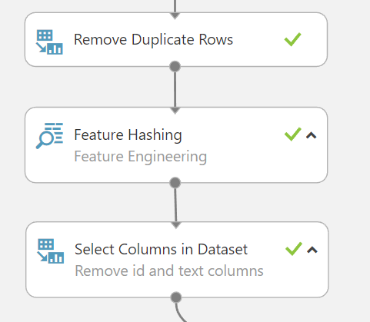

Modeling and evaluation

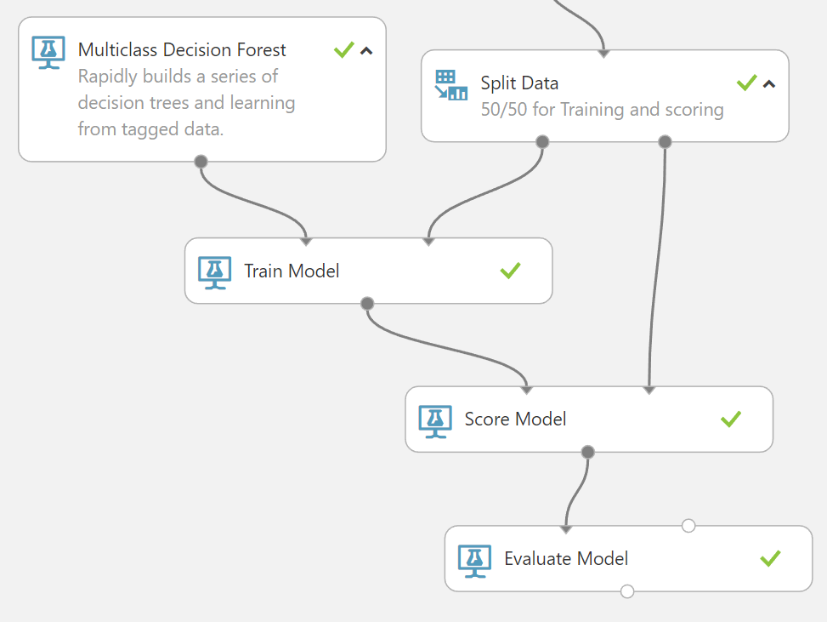

Reuter Data set

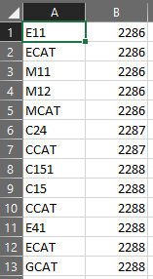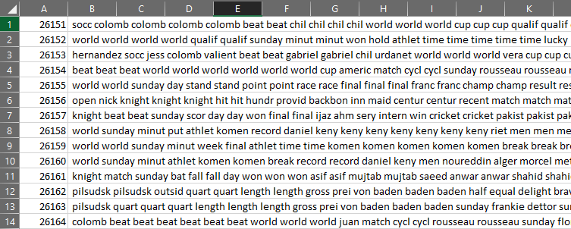

Data set has 103 categories that are organized into four hierarchies:

* Corporate-Industrial (CCAT)
* Government and Social (GCAT)
* Economics and Economic Indicators (ECAT)
* Securities and Commodities Trading and Market (MCAT)
* 2004 Reuters news dataset
* 10,000 News examples
* 5K Training / 5K Scoring

Import data set

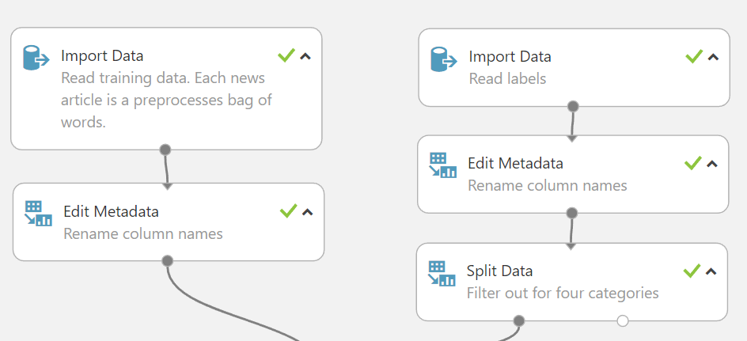

**A**

**B**

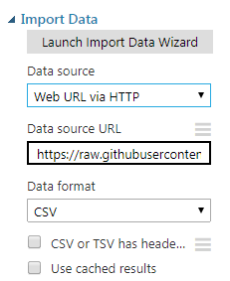

A = https://raw.githubusercontent.com/laploy/ML/master/mul.csv

B = https://raw.githubusercontent.com/laploy/ML/master/mul_token.csv

Edit Metadata

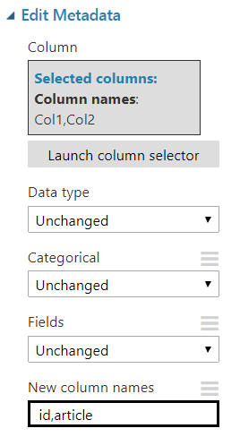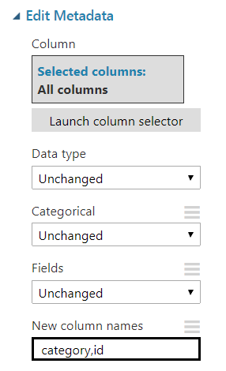

**A**

**B**

Splitting Data

Used only the rows already tagged with hierarchy names (CCAT,ECAT,GCAT,MCAT)

**After splitting**

**Before splitting**

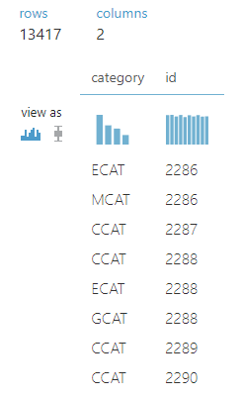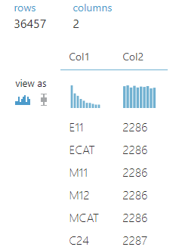

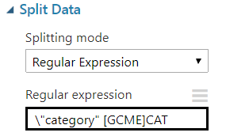

Feature & Clean

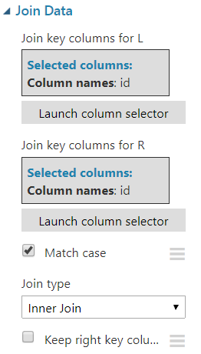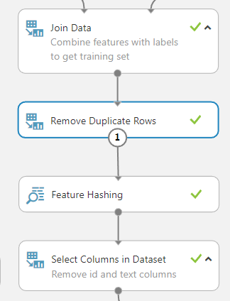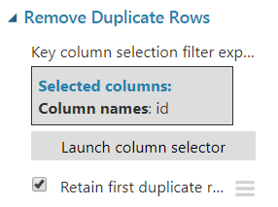

Feature Engineering

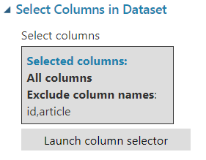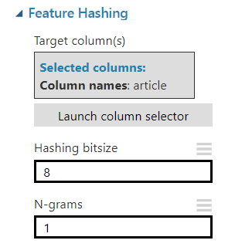

Algorithm

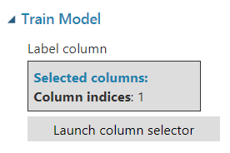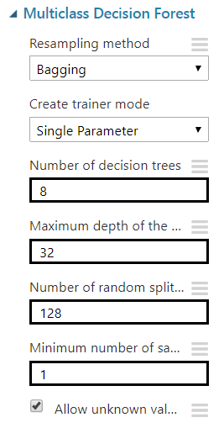

Confusion Matrix

Test data = <https://raw.githubusercontent.com/laploy/ML/master/mul-test.txt>

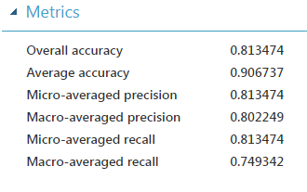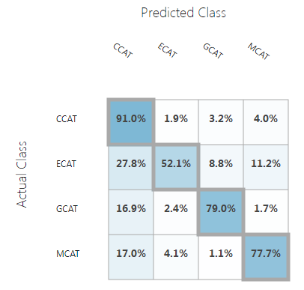

More information

Multiclass Decision Forest

<https://msdn.microsoft.com/en-us/library/azure/dn906015.aspx>

This Experiment

<https://gallery.cortanaintelligence.com/Experiment/Multi-Class>